Product Catalog | SIM card connector
Card connection way | Self-ejecting
Card type | NanoSIM card
Connector Type | Card slot
Max. body height | 1.25mm
Contact material | Copper Alloy
Contact plating | Gold Plated
Operating temperature range | -40℃~+85℃
Soldering temperature (max.) | 260℃
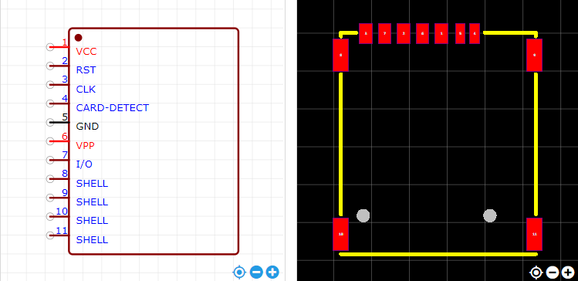
https://item.szlcsc.com/353303.html

